- In tree-based methods, there are the expressions “Bagging” and “Boosting”. What do they mean and what is the difference between them?

What Is the “Bagging” Ensemble Method?

What are Weak Learners & Strong Learners for Machine Learning?
- What are the similarities between Bagging and Boosting?

- What are the dissimilarities between Bagging and Boosting?

Why is bagging better than boosting?

In tree-based methods, there are the expressions “Bagging” and “Boosting”. What do they mean and what is the difference between them?

Bagging is short for “bootstrap aggregation”. What does this mean? It means bringing together trees obtained by resampling method. In this respect, it brought a completely different perspective to single tree structures and moved the machine learning world forward. In this method, new trees are created by taking samples from the sample data set to replace them, and a community emerges from these trees. So the tree community. For this reason, it is referred to as community learning methods. All of the resulting trees are used for modeling, and each is asked about their ideas. The opinion of each is evaluated and a voting / average opinion is obtained and the result of the estimation process is presented as a single statement. Bagging should be seen as a methodology. For example, when the CART algorithm is connected, a bagged tree appears. When the CART algorithm is linked on the basis of both observation and variable, Random Forests emerges.
Another expression of the result of this effort: randomness on the basis of observation and variable is achieved, the problem of over-learning is eased, and the prediction success increases.
Boosting methods are expressed in a single sentence: now tries to increase performance based on optimization. So models are adaptive. There is a cumulative error evaluation. Boosting should also be seen as a methodology. AdaBoost derives its Gradient Boosting Machines, XGboost features from this “boost” approach. At its core is the idea of putting weak classifiers together. The algorithmic equivalent of this idea is to create a series of models in the form of a single predictive model. A model in the series is created by building (fit) over the prediction residuals or residuals of the previous model in the series. Here, the concept of adaptive learning will be better understood. Trees are dependent, not independent.
This is the key difference between bagging and boosting. Whether the trees to be created have dependencies with the previous trees and whether the error optimization is cumulative over the residuals.
As a result, the algorithms where the ideas of working with more than one tree, using randomness in observation and variable selection, creating independent trees or dependent trees reach the top by blending them are algorithms such as GBM, XGboost and LightGBM. The most fundamental very subtle issue is to try to provide RANDOMITY.

What Is the “Bagging” Ensemble Method?
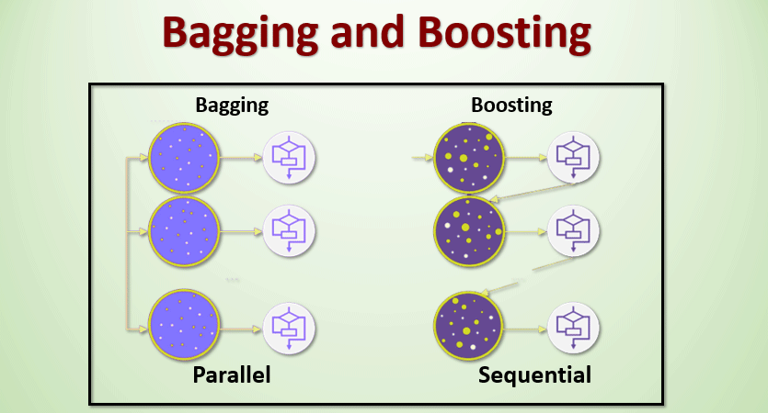
Behind idea in bagging is to combine the results of multiple models (eg all decision trees) to produce a more general result.
The ones that come to mind are:
- Would it be useful if you create and merge all models on the same dataset?
- Since they take the same input, these models have a high chance of producing the same result.
- How can solve this problem?
Bootstrapping technique:
We can call this method a sampling technique that we create by changing subsets of observations from the original data set. With subsets, it is the same size as the original set.
Bagging technique:
The Bootstrapping and Bagging technique uses these subsets to get a fair idea of the whole set. The size of the subsets generated for bagging may be less than the original set.
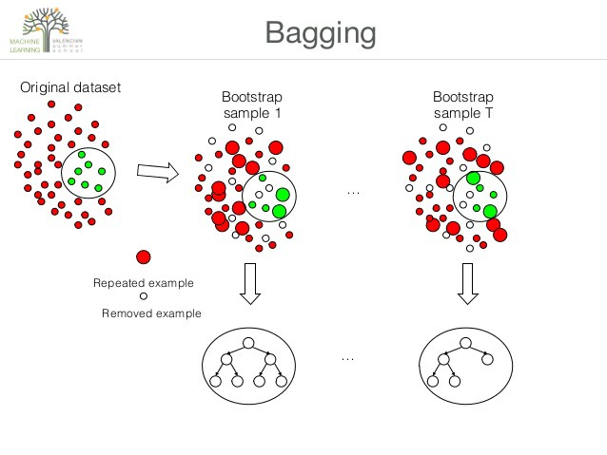
- Multiple subsets(samples) are created from the original dataset(super population), selecting observations with replacement.
- A base model (weak model) is created on each of these subsets.
- The models run in parallel and are independent of each other.
- The final predictions are determined by combining the predictions from all the models.
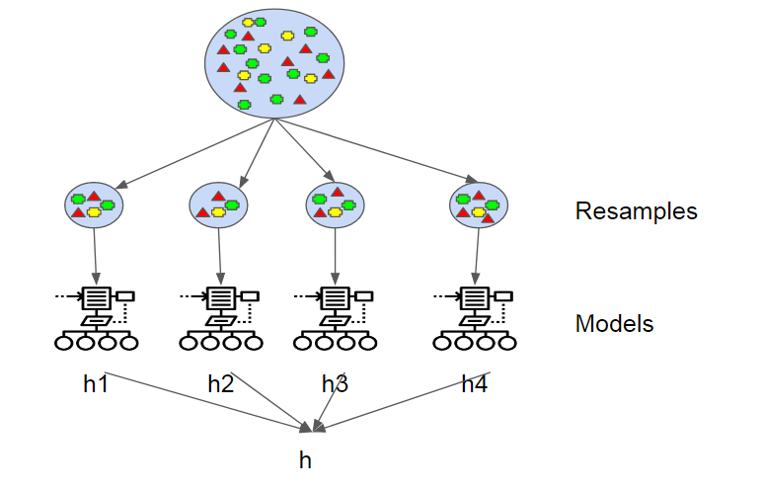

What are Weak Learners & Strong Learners for Machine Learning?
In both, homogeneous and heterogeneous ensemble methods we said that the individual models are called weak learners, in the homogeneous ensemble method these weak learners are built using the same ML algorithms, whereas in the heterogeneous ensemble methods these weak learners are built using different ML algorithms.
The questions are:
- So what do these weak learners do?
- Why are they more important for understanding any ensemble methods?
Weak learning is the same as any ML model, unlike the strong ML models they won’t try to generalize for all the possible target cases. The weak learners only try to predict a combination of target cases or a single target accurately.
Are you confused?
Try to understand this with an example. Before that, we need to understand about bootstrapping. Once we learn about bootstrapping, then we will take an example to understand weak learning and strong learning methodology in more detail.

Bootstrapping
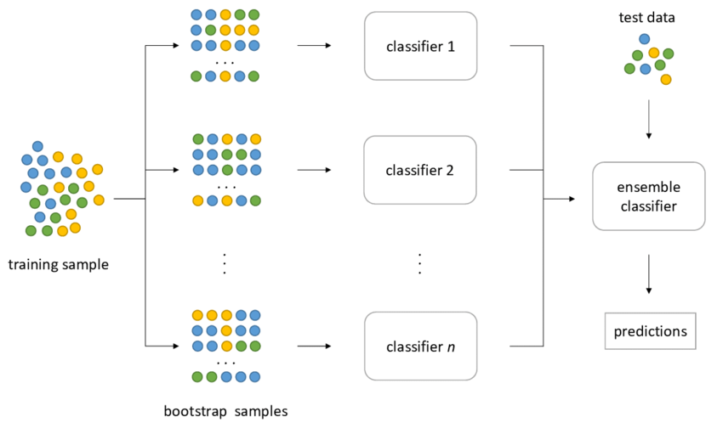
https://hudsonthames.org/bagging-in-financial-machine-learning-sequential-bootstrapping-python/
For building multiple models whether it is a homogeneous or heterogeneous ensemble method the dataset is the same.
So how to use the same dataset for building multiple models?
For each model, we need to take a sample of data, but we need to be very careful while creating these samples of data. Because if we randomly take the data, in a single sample we will end up with only one target class or the target class distribution won’t be the same. This will affect model performance.
To overcome this we need a smart way to create these samples, known as bootstrapping samples.
Bootstrapping is a statistical method to create sample data without leaving the properties of the actual dataset. The individual samples of data called bootstrap samples.
Each sample is an approximation for the actual data. These individual sample has to capture the underlying complexity of the actual data. All data points in the samples are randomly taken with replacement.
Above image from the actual dataset, we created 3 bootstrap samples. In this case, we are creating an equal size sample. We don’t have any hard rule saying all the bootstrap sample sizes should be the same.
In the bootstrapping properties, we said that the data points will take randomly and with replacement. From the above image, the second bootstrapping sample is having a repeated data point (this is light green).
Same as the above image, using the actual dataset we will create bootstrap samples. Then each bootstrap sample is used to create multiple models.
By now we have learned how the individual sample datasets are created and we also learned these datasets are used for building the multiple weak learners. The combination of all weak learners makes a strong learner or strong model.

1. Weak Learners
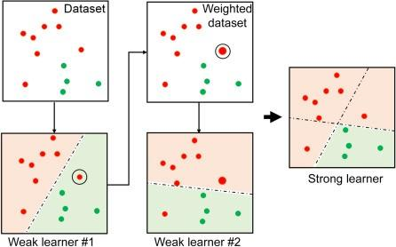
https://www.sciencedirect.com/topics/engineering/adaboost
Let’s try to understand about weak learning with the help of the above example.
Week learners are the individual models to predict the target outcome. But these models are not the optimal models. In other words, we can say they are not generalized to predict accurately for all the target classes and for all the expected cases.

What are the similarities between Bagging and Boosting?

Bagging and Boosting: Similarities
- Bagging and Boosting are ensemble methods focused on getting N learners from a single learner.
- Bagging and Boosting make random sampling and generate several training data sets
- Bagging and Boosting arrive upon the end decision by making an average of N learners or taking the voting rank done by most of them.
- Bagging and Boosting reduce variance and provide higher stability with minimizing errors.

What are the dissimilarities between Bagging and Boosting?
Bagging is a method of merging the same type of predictions. Boosting is a method of merging different types of predictions.
Bagging decreases variance, not bias, and solves over-fitting issues in a model. Boosting decreases bias, not variance.
In Bagging, each model receives an equal weight. In Boosting, models are weighed based on their performance.
Models are built independently in Bagging. New models are affected by a previously built model’s performance in Boosting.

Why is bagging better than boosting?
From the dataset, bagging creates extra data for training. Random sampling and substitution from the original dataset is used to achieve this. In each new training data set, sampling with replacement may repeat certain observations. Every Bagging element has the same chance of emerging in a fresh dataset. Multiple models are trained in parallel using these multi datasets. It is the average of all the forecasts from several ensemble models. When determining classification, the majority vote obtained through the voting process is taken into account. Bagging reduces variation and fine-tunes the prediction to a desired result.

